Let us create a nested query for fetching the student details and their college details.

## Step 1 − Download and Install Required Dependencies for the Project

Create new package.json file with below code and install all dependencies.

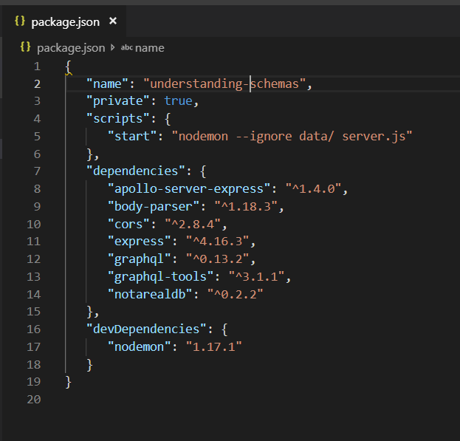

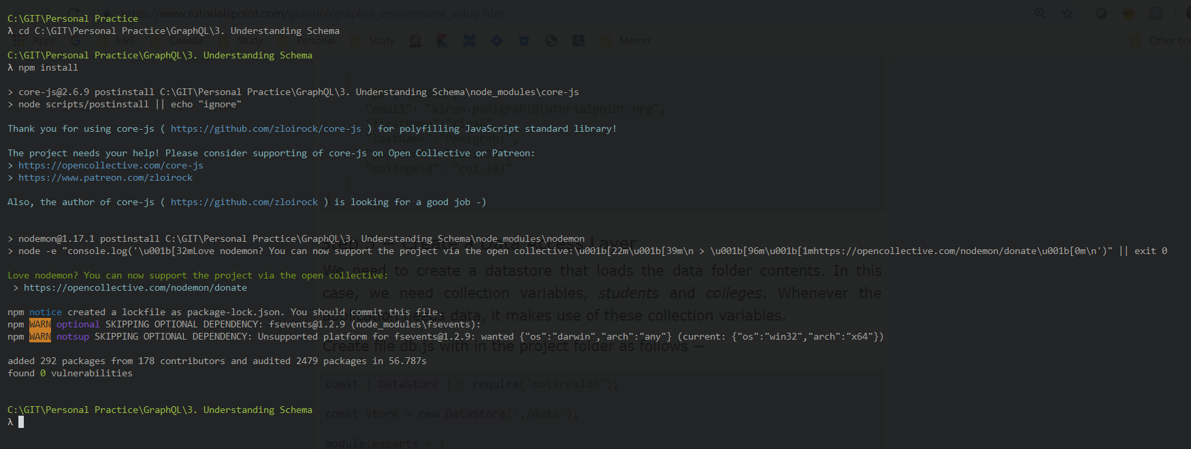

**Create Flat File Database in Data Folder**

we use flat files to store and retrieve data.

Create a folder data and add two files **students.json** and **colleges.json**.

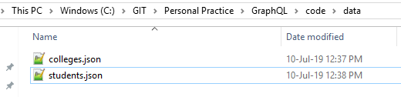

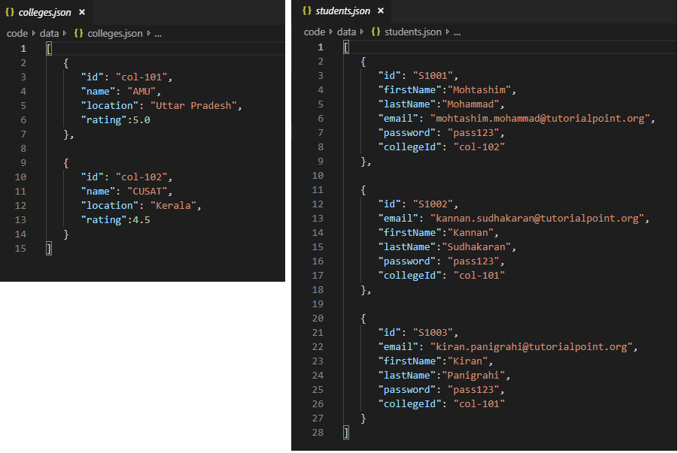

**Create a Data Access Layer**

We need to create a datastore that loads the data folder contents.

In this case, we need collection variables, *students* and *colleges*.

Whenever the application needs data, it makes use of these collection variables.

Create file db.js with in the project folder as follows

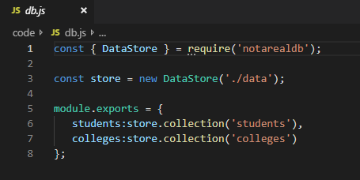

## Step 2 − Create a Schema

Add **schema.graphql** file with following code.

The schema file already has the student field. Let us add a field college and define its type.

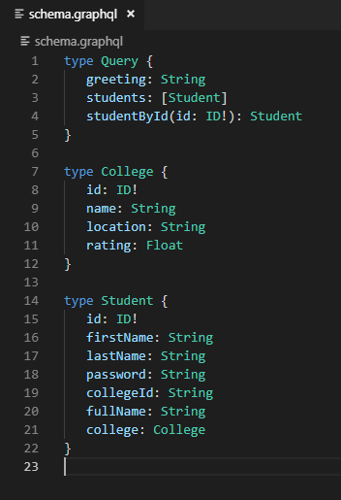

## Step 3 − Create Resolver

Create a file **resolvers.js** with following code.

We need to add a college resolver function. The college resolver function will be executed for each student object returned. The root parameter of resolver in this case will contain student.

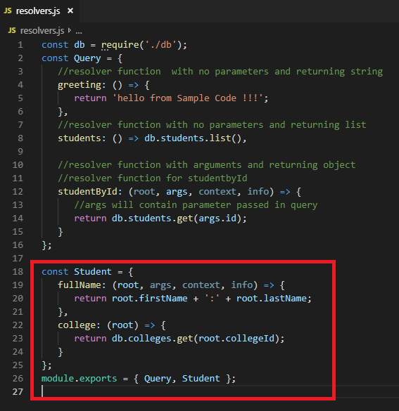

The resolver returns college of each student by calling the get method of college collection and passing the *collegeId*.

We have association relationship between Student and College through the *collegeId*.

## Step 4 − Run the Application

Create a server.js file.

